**Вариант 2 Раздел Аудирование**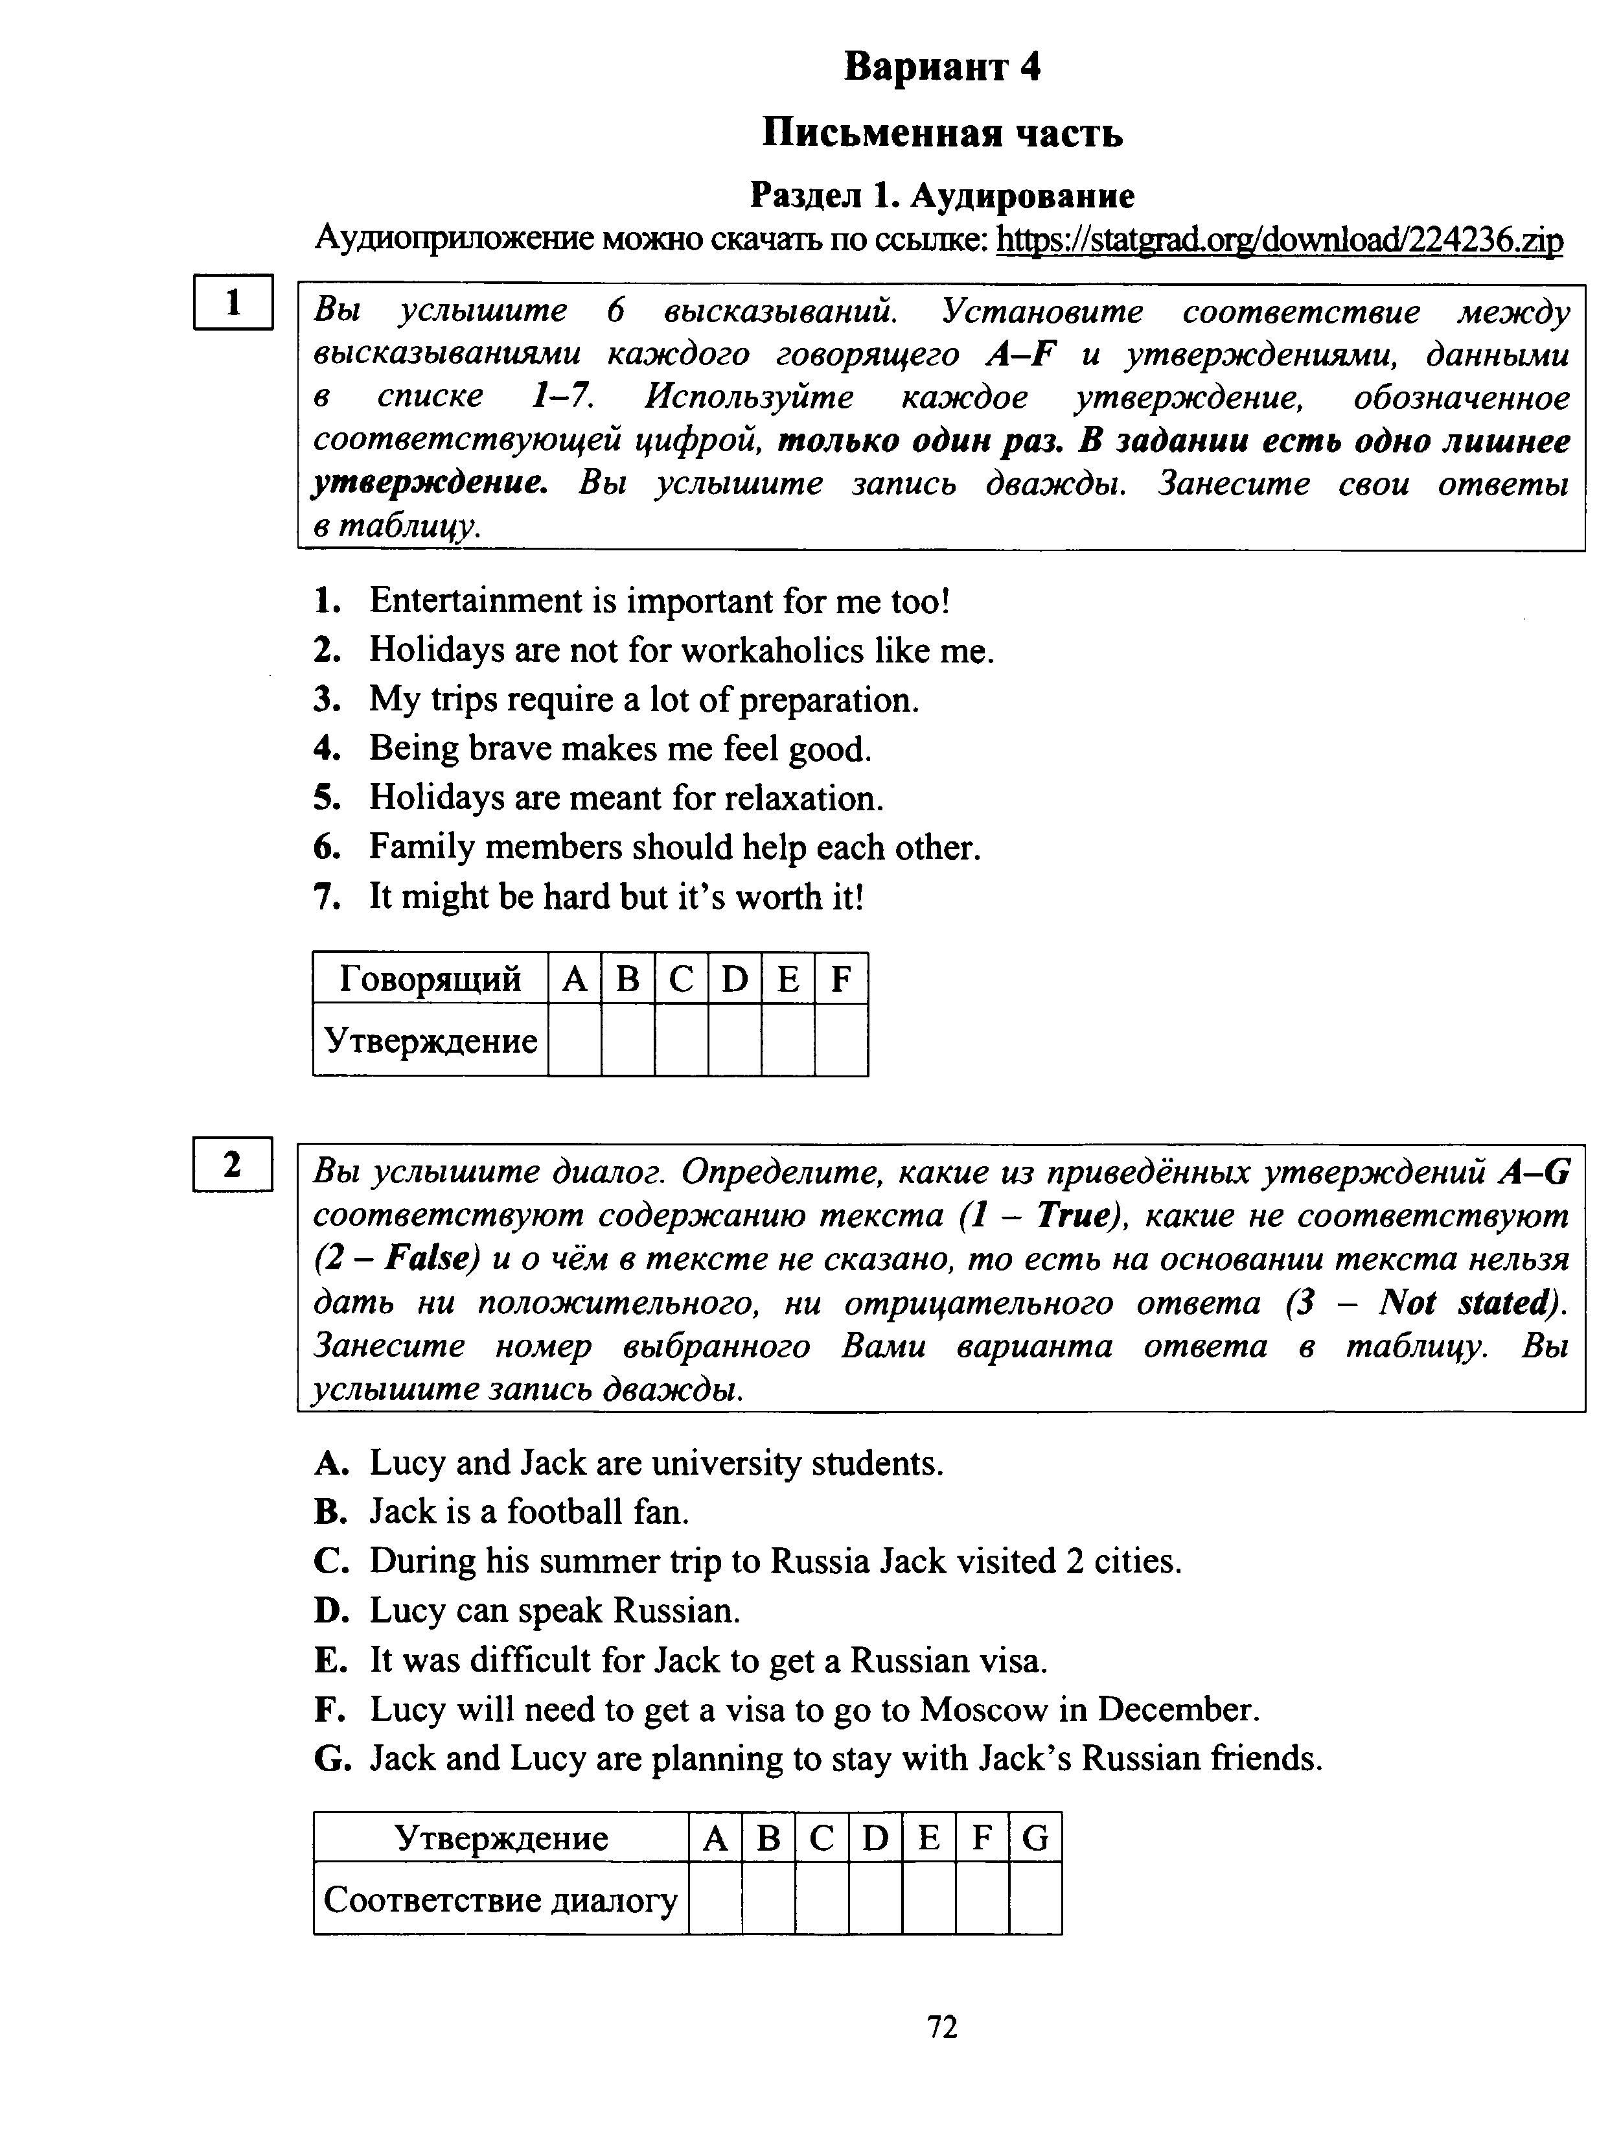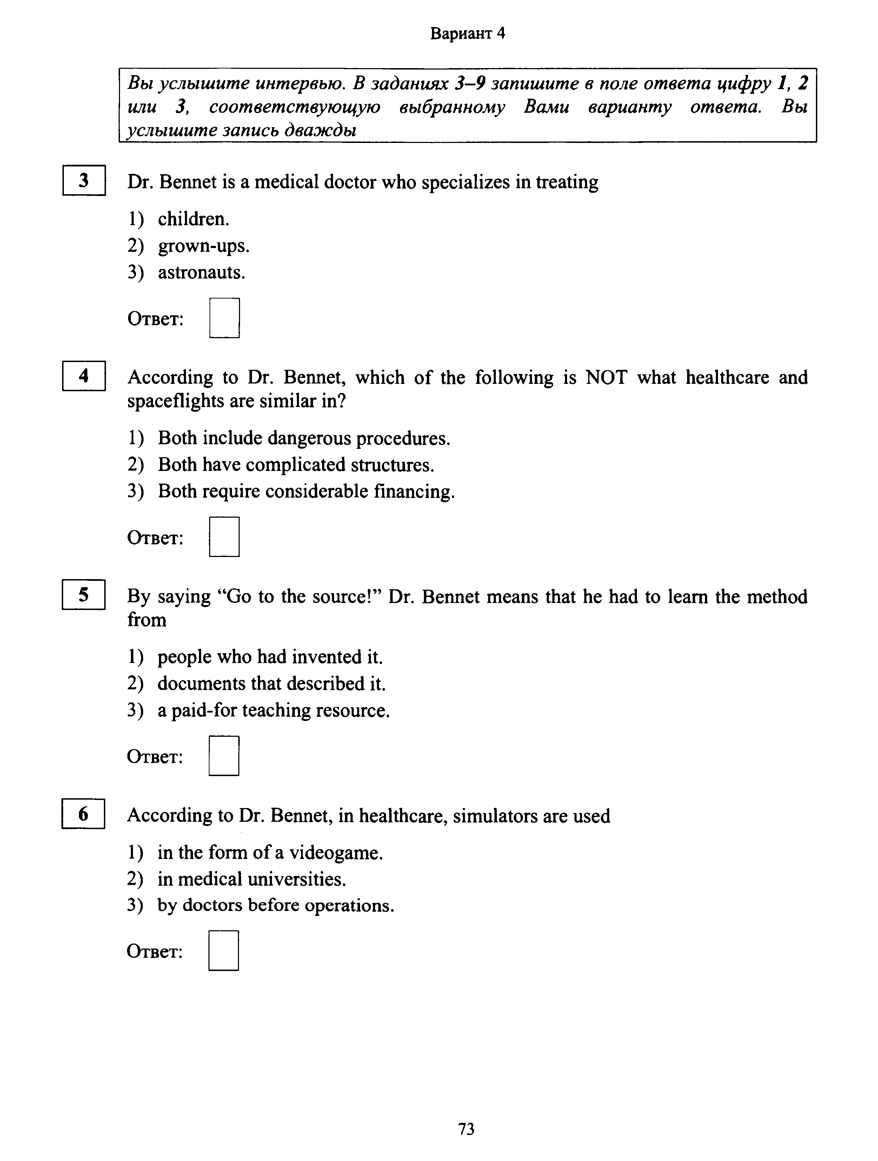

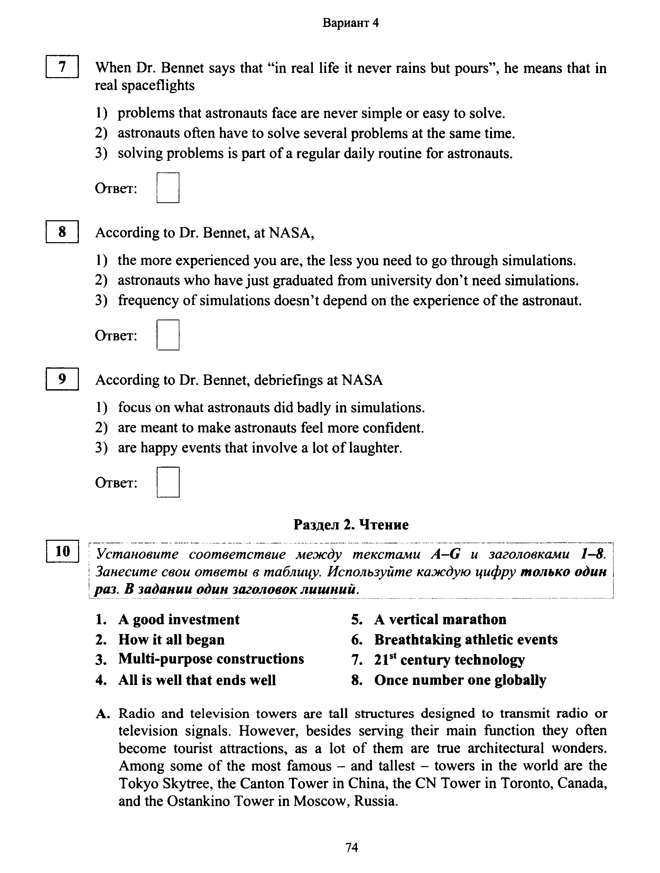

**Раздел Чтение**

**10** Установите соответствие между текстами A–G и заголовками 1–8. Занесите свои ответы в таблицу. Используйте каждую цифру только один раз. В задании один заголовок лишний.

1. Order above all 5. Apart from education2. Ready to take charge 6. Part of a team3. Adaptable to change 7. Words and gestures4. Lest you should be fired 8. Reasonable beings

A. If you’re going to get a dream job of yours, you need to deliberately set your skill set and resume apart from the thousands more out there. This requires thinking not only about degrees and certificates, but also about soft skills that could make you the perfect candidate for the job. You could drastically improve your chances of finding your dream job by simply improving on some most sought after real-life job skills that employers are looking out for right now.  
B. Your stellar ideas aren’t of much value if they can’t be adequately expressed to other members of a team. Effective communication skills are therefore a must in order to efficiently exchange information with co-workers, bosses and clients. It is important to note that non-verbal communication is just as important. Modern market offers a myriad of online courses one can take to improve one’s communication skills, which are keenly desired by employers and employees.  
C. Regardless of the type of job openings that exist within a firm, employers eagerly look out for signs of leadership qualities in potential employees. The ability to take responsibility and manage not only oneself but one’s co-workers as well increases one’s worth in the eyes of employers. This is especially true for companies where employees are more likely to quickly climb up the corporate ladder and get promoted into managerial positions.  
D. In every job fathomable you most likely will need to work with other people frequently by way of exchanging ideas, collaborating on projects, and coming together to solve problems. People who find it difficult to cooperate with others and accept their input can be problematic, and this could very easily lead to

conflicts in the work environment which would inevitably result in a decline in productivity — something every employer dreads.  
E. Organization remains a skill employers actively look out for. It is much easier for a person who respects and follows some method of organization to understand the work process in any firm. Organizational skills can range from how a person writes a simple daily report to how their workspaces are arranged. Even though an unsystematic technique might sometimes produce desired results, an organized approach is far more desirable and efficient.  
F. Employers are interested in critical thinkers. One never assumes that the information provided is sufficient. They look beyond the basic details available and able to see things from different perspectives in order to figure out the best course of action. These people are more likely to deal with analysis of facts than with emotion. Instead of simply going by their gut feeling, they carry out proper research in order to arrive at solutions that are backed by proof.  
G. The discipline required to do whatever needs to be done on time is a skill employers attach a great deal of value to. This means arriving at the office on time regardless of traffic constraints, being ready and seated before a meeting commences, and generally beating work deadlines. Time is money. Bearing this in mind, a person who takes punctuality with levity is ultimately a burden to the company, and no employer will endure that for long.

**Задание 11** Прочитайте текст и заполните пропуски A–F частями предложений, обозначенными цифрами 1–7. Одна из частей в списке 1–7 лишняя. Занесите цифры, обозначающие соответствующие части предложений, в таблицу.

The Impressionists and the Wanderers

The artistic life in Russia and in France in the late nineteenth century had a lot in common. The art of French Impressionists and Russian artists called ‘Peredvizhniki’ or ‘The Wanderers’ had different philosophies and views of life, but both opposed academism in painting. In fact A _______________, to achieve similar goals. Back in 1860-s the painters of those two groups were yet very young people, who were B _______________, where the training was mostly academic. Claude Monet claims that his teacher, Charles Gleyre, told him that whatever he paints, he must keep the classical antique models in the back of his mind. This was quite different from the young artist’s view of C _______________. So after two weeks Monet left the Academy with his friends Auguste Renoir, Alfred Sisley and Frederic Bazille. Quite fascinating that a Russian painter, Ivan Kramskoy, describes the same thing happening to him at the Academy of arts in Russia. His teacher told him that he should learn from classical antique masters, rather than D _______________. Just as Claude Monet did, Ivan Kramskoy left the Academy with some of his friends and developed his own method of painting. Some years later, Ilya Repin, Vassily Surikov, Ivan Shishkin and other famous painters joined the Wanderers art society. Of course at first both the Impressionists and the Wanderers were rejected by other artists. All through the 1860-s their pictures were not displayed at the exhibitions in the capital cities. But gradually the art society started E _______________ and manner of painting. The first exhibition of the Wanderers took place in 1871, while the first exhibition of the Impressionists was in 1874. By the 1880-s the Wanderers and the Impressionists F _______________ and commercial success. But in the early 1890-s their methods have had to face the crisis. So the next generation of artists had to discover new depictive patterns that further on took us into the world of contemporary art.

1. attending art schools

2. trying to be realistic

3. enjoyed critical acclaim

4. they followed different ways

5. learned to paint well

6. to appreciate their style

7. what art should be

**Задание 3.** Прочитайте текст и выполните задания 12–18. В каждом задании запишите в поле ответа цифру 1, 2, 3 или 4, соответствующую выбранному Вами варианту ответа.

Liking and loving: what’s the difference?

A couple of weeks ago, I replaced my three-year-old smartphone with a new one. Needless to say, I was impressed with how far the technology had advanced in three years. Even when I didn’t have anybody to call or text or e-mail, I wanted to keep holding my new smartphone and experiencing the marvelous clarity of its screen, the silky action of its track pad, the shocking speed of its responses, the delightful elegance of its graphics.

I was in love with my new device. I’d been similarly in love with my old device, of course; but over the years I’d developed trust issues, compatibility issues and even some doubts about its sanity, until I’d finally had to admit tomyself that our relationship was over. Do I need to point out that our relationship was entirely one-sided? Let me point it out anyway. Let me further point out that hi-tech companies create products that correspond to our ideal of a relationship, in which the beloved object asks for nothing and gives everything, and doesn’t make terrible scenes when it’s replaced by another object.

To speak more generally, the ultimate goal of technology is to replace a natural world that’s indifferent to our wishes with a world so responsive to our wishes as a mere extension of ourselves. Let me suggest, finally, that the world of techno-consumerism is troubled by real love, and that it has no choice but to commercialize love in turn. You can all supply your own favorite examples of the commercialization of love. Mine include the wedding industry, TV ads that feature automobiles as Christmas presents, and comparing the diamond jewelry to everlasting devotion. The message, in each case, is that if you love somebody you should buy stuff.

A related phenomenon is the transformation of the verb ‘to like’ from a state of mind to an action that you perform in social networks. And liking, in general, is a commercial substitute for loving. The striking thing about all consumer products is that they’re designed to be immensely likable. This is, in fact, the definition of a consumer product, in contrast to the product that is simply itself, like jet engines, laboratory equipment, serious art and literature. But if you imagine a person who only cares about being liked, you see a person without integrity, without a center. If you dedicate your existence to being likable, it suggests that you’ve despaired of being loved for who you really are.

There is no such thing as a person whose real self you like every particle of. This is why a world of liking is ultimately a lie. But there is such a thing as a person whose real self you love every particle of. And this is why love is a threat to the techno-consumerist order: it exposes the lie. When you love a specific person, you identify your-self with his or her struggles and joys as if they were your own. The big risk here, of course, is rejection. We can all handle being disliked now and then, but to expose your whole self and to have it rejected can be catastrophically painful. The prospect of rejection makes us to avoid love and stay safely in the world of liking. And yet pain hurts but it doesn’t kill.

When I was in college, and for many years after, I liked the natural world. Didn’t love it, but definitely liked it. But then a funny thing happened to me. It’s a long story, but basically I fell in love with birds. I think that my love of birds became a portal to an important, less self-centered part of myself that I’d never even known existed. Instead of continuing to drift forward through my life as a global citizen, I was forced to confront my true inner self that I had to either accept or reject. Because the fundamental fact about all of us is that we’re only alive for a while. And you can either run from this fact or, by way of love, by way of sacrificing yourself for the sake of someone else, you can embrace it.

12. The author describes how much he was fond of his new …

1) e-mail. 2) track pad. 3) smartphone. 4) screen.

13. Which of the following statements is TRUE, according to the text?

1) The relationship always breaks because of the lack of trust.

2) Our attitude to electronic gadgets today is similar to a relationship.

3) One of the most important qualities in any relationship is compatibility.

4) You can’t have a good relationship with a person if you doubt his sanity.

14. The wrong idea of consumerism is that if you love someone …

1) you should buy things for him. 2) you should care for him.

3) he should love you in turn. 4) you should be troubled by it.

15. Which of the following qualities, according to the author, all the consumer products must have?

1) They have to be very likeable. 2) They must be quite reliable.

3) They should be functional. 4) They need to be inexpensive.

16. The author states that exposing your love to another person and being rejected can be very …

1) cheerful. 2) grateful. 3) painful. 4) playful.

17. As the author puts it, — pain hurts, but it doesn’t …

1) heal. 2) kill. 3) kneel. 4) seal.

18Just as the author has become very interested in birds, he became less

… 1) self-centered. 2) self-oriented. 3) self-conscious. 4) self-sufficient.

**Раздел 3. Грамматика и лексика**

Задание 1 Прочитайте приведённые ниже тексты. Преобразуйте, если необходимо, слова, напечатанные заглавными буквами в конце строк, обозначенных номерами 19–24, так, чтобы они грамматически соответствовали содержанию текстов. Заполните пропуски полученными словами. Каждый пропуск соответствует отдельному заданию из группы

19–24.

Since the very first state was formed, people 19)__________ . **(KEEP)**

dreaming of the ideal form of social organization with liberty and justice for all the citizens One of the first writers, who 20)__________ the idea of **CREAT**

a perfect state, was Plato, that lived in ancient Greece.) His famous book ‘The Republic’ that describes the city-state, ruled by a

philosopher king, 21) _________ in a form of a dialogue. **(WRITE)**

In the year of 1516, an English author, Thomas More, published a book ‘Utopia’, that 22) _________ an ideal state, located on an island. **(DESCRIBE)**

But by the name of the book ‘Utopia’, which means ‘a place that doesn’t exist’, one may judge that Thomas More 23) ________ too optimistic about (**NOT BE)**

the future of the mankind .

The ideas of Plato and Thomas More 24) _______ later by Tommaso Campanella in his book **(USE)**

‘The City of the Sun’. Today the word ‘utopia’ has become

a part of everyday our language, for instance, if the idea is unrealistic we may call it ‘utopian’

Задание 2 Прочитайте приведённый ниже текст. Образуйте от слов, напечатанных заглавными буквами в конце строк, обозначенных номерами 25–29, однокоренные слова, так, чтобы они грамматически и лексически соответствовали содержанию текста. Заполните пропуски полученными словами. Каждый пропуск соответствует отдельному заданию из

группы 25–29.

Now, the whole district of the St. Bernard for many miles around possesses not one of the vast caravansaries characteristic of the 25)**____________ (PICTURE**)

mountain-tops in Switzerland, —indeed, not even a modest inn, —where tourists may find shelter for a few days.

Why, then, should these armies of tourists invade the pass every summer, if it really offers little of interest? To me, who have seen almost all the passes from one end of the Alps to the other, the trip over

the Great St. Bernard was most 26)_____________. **(ENJOY**)

The valley of the river Dranse, which is followed by the traveler from Martigny, in the Rhone valley, to very near the summit, more than eight thousand feet above the sea, is full of romantic beauty and 27) **____________, (WILD)**

closed in by snow-covered mountains of fantastic shapes, their steep slopes partly covered with dark pine forests. Nestling on the rocks or sleeping in the valleys there are a few straggling settlements, with heavy-visaged natives, apparently of a different race from the Swiss,

and entirely28) ______________ by modern life. **(TOUCH)**

Many wayfarers stop at the modest inns to rest and take a glass of kirsch, or even to seek shelter in the old houses when storms spring up suddenly, blowing 29)___________ down the valleys. (**FURY)**

Прочитайте текст с пропусками, обозначенными номерами 30–36. Эти номера соответствуют заданиям 30–36, в которых представлены возможные варианты ответов. Запишите в поле ответа цифру 1, 2, 3 или 4, соответствующую выбранному Вами варианту ответа.

To travel or not to travel

I have always been thinking if the cost of travelling compensates the experience. Travelling is such a pleasure. Imagine going around the world experiencing all the different things that aren’t the same in your home country. Travelling gives you a great thing to put on applications because it shows that you are (30) _________ to travel and understand travelling for work. With travelling you could literally go anywhere in the world. You could never (31) _________ out of different places to visit because there are so many! Entering a new country usually changes your views about everything. Another thing with travelling is the cultural exchange you get. The best way to do it is communicating with local people. So, I usually tend to (32) ________ away from all the touristy areas to feel more like the locals.

(33) _________, travelling does have a disadvantage … the cost. Travelling not by yourself but with your family along is more expensive. But one way to save is going on cruises. They are the best for big families and if you want to see many places in a short period of time. Another tip to (34) _____________ the cost of travelling is to follow other travelers’ advice. Some of them launch blogs, travel vlogs on YouTube Channel and post pictures on Instagram to keep a record of their journeys and let people back home know what they’re (35) _________ to as well as share their travel tips, costs and stories. This information can help other travelers budget for their trip and (36) ____________ an eye on their spendings. All in all I think travelling is worth taking!

1. 1) versatile 2) flexible 3) responsive 4) nimble
2. 1) run 2) get 3) move 4) be
3. 1) stand 2) stay 3) step 4) stick
4. 1)consequently 2) moreover 3) however 4) therefore
5. 1) lessen 2) cut down 3) reduce 4) decline
6. 1) up 2) about 3) round 4) down

36: 1) have 2) keep 3) put 4) hold

**Задание 37**

**From: Gloria@mail.uk______________________  
To: Russian_friend@ege.ru__________________  
Subject: Moving____________________________**

... Next week we are moving to California! My dad found a good job there. This will be the fourth time in my life that we pack and go to a new place! How many times have you moved in your lifetime, if any? What would be the house or apartment of your dreams? Where would you like to live when you grow up?   
By the way, in our new place we will have a vegetable garden!

Write a letter to Gloria.  
In your letter  
– answer her questions  
– ask 3 questions about the vegetable garden.  
Write 100–140 words.  
Remember the rules of letter writing.  
**Задание 38.1**

Imagine that you are doing a project on lodging preferences during holidays in Zetland. You have found some data on the subject – the results of the opinion polls (see the table below). Comment on the data in the table and give your opinion on the subject of the project

**Accommodation Type Choice in Tourism**

|  |  |
| --- | --- |
| Accommodation Type | Respondents (%) |
| Hotels | 47% |
| Apartments | 19% |
| B&B (Bed and Breakfast) | 13% |
| Hostels | 11% |
| Guest-houses | 10% |

Write 200–250 words. Use the following plan:

− make an opening statement on the subject of the project;

− select and report 2–3 facts;

− make 1–2 comparisons where relevant and give your comments

− outline a problem that can arise with accommodation during holidays and suggest a way of solving it;

− conclude by giving and explaining your opinion on the importance of accommodation for vacationers.

**Задание 38.2**  
Imagine that you are doing a project on **why teenagers in Zetland value friendship**. You have found some data on the subject – the results of the opinion polls (see the pie chart below). Comment on the data in the pie chart and give your opinion on the subject of the project.

**Why friendship is the greatest value.**

Use the following plan:

− make an opening statement on the subject of the project;

− select and report 2–3 facts;

− make 1–2 comparisons where relevant and give your comments;

− outline a problem that one can face making friends and suggest a way of solving it;

− conclude by giving and explaining your opinion on the importance of friendship in our life.